Attaching your i-Pad to the Garmin GTX345

- Power unit up.
- Press the function button until SYS” is displayed.
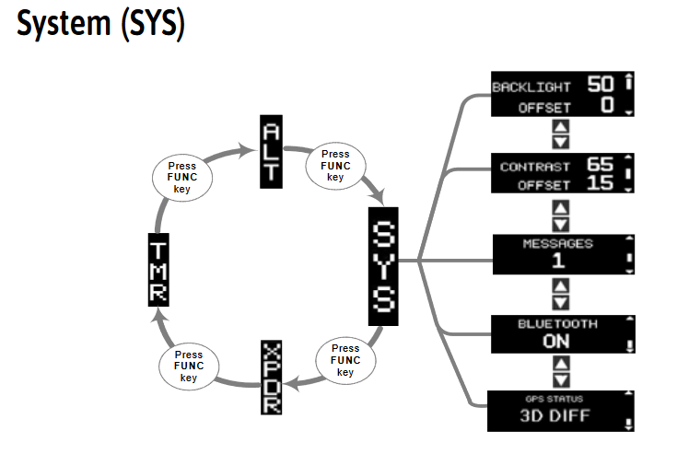
- Use the arrow until the screen says Bluetooth ON.
  - This page displays the status of the GTX 345 Bluetooth function. The Bluetooth function is automatically placed into pairing mode when this page is displayed. Pairing must be initiated by the Personal electronic device (PED) and then confirmed on the GTX 345. The last 13 paired PEDs are saved. At system power on, the GTX 345 automatically connects to any available and previously saved paired PEDs. PEDs that are currently connected and paired are viewed/deleted via the CRSR and 8 and 9 keys.
- For first time activation of Bluetooth devices:
  - Go to the GTX 345 Bluetooth page to enable pairing mode. (Refer to figure 3-3.)
  - Enable Bluetooth on the PED.
  - Select “GTX 345” from the list of available devices on the PED. When a PED sends a pairing request the Bluetooth Pair Request page will display the device name and passkey.
  - (Refer to figure 3-4.) Press ENT on the GTX 345 and accept the pairing request on PED.
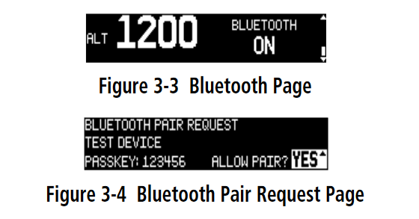

iPad Screen Examples
